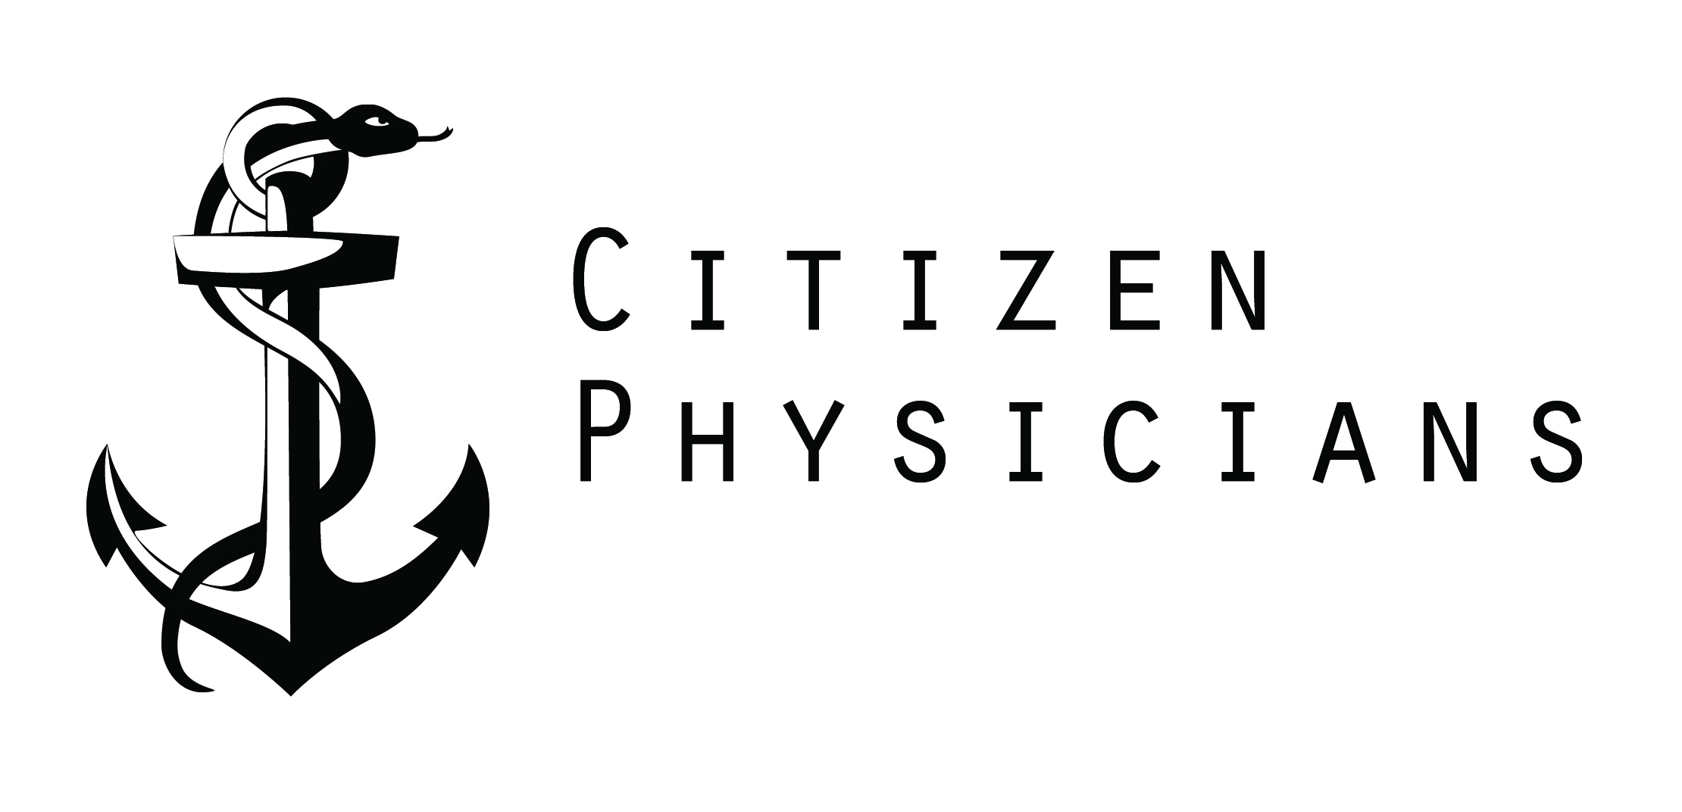

***THIS EMAIL WAS SENT BY THE BROWN CHAPTER OF CITIZEN PHYSICIANS TO ALL FOUR YEARS OF MEDICAL STUDENTS AT THE ALPERT MEDICAL SCHOOL OF BROWN UNIVERSITY ENCOURAGING STUDENTS TO VOTE IN RHODE ISLAND'S PRIMARY ELECTION. WE HOPE SHARING THIS EMAIL MAY SERVE AS A TEMPLATE FOR OTHER STUDENTS TO SEND SIMILAR EMAILS TO THEIR CLASS LISTSERVS.***

Hi AMS,

This is a friendly reminder from Citizen Physicians that RI's primary election is NEXT WEEK on Tuesday, 4/26!

Take a look at the ballot before Tuesday so you know what to expect (you can only vote on either the Republican or the Democratic ballot).

You can confirm where your polling place is here.

Make sure you know when your polling place opens and closes (Providence polling places are open from 7am to 8pm). As long as you're in line by 8pm you should be allowed to vote.

Voting is a civic responsibility. We encourage every medical student to vote. Clinical faculty should not discourage anyone from exercising their right to vote. If you receive any pushback, though, please let us know.

Please don't hesitate to let me or anyone else on the Citizen Physicians team know if you have any questions.

Sincerely,

Your Citizen Physicians Chapter

